NAME: _______________________________________________
Computer Science - Fall, 2014
Server-Side Web Development

CS 321

ASSIGNMENT 2, Part 1(due Monday/Tuesday, September 22/23, 2014) (20 points)
Assignment 2, Part 1 will be comprised of two related web pages (and their corresponding aspx.cs pages).

The primary page will be a “Bill To/Send To” address form.

The purpose of the form is to collect billing and shipment information for an online retail business.

The form is to be divided into two sections, information for the billing address and information for the shipping address. The fields to be included are the following:
- First Name
- Last Name
- Street
- City
- State
- ZIP Code
Both the billing section and the shipping section will request the above data items. The shipping section will include an additional checkbox field that is to be checked by the user to indicate that the shipping address is the same as the billing address. If the checkbox is left “unchecked” the user must fill out the data for the shipping address. If the box is checked, the form is to be posted back to the server, and the data from the billing section is to be filled into the appropriate fields in the shipping section.

Finally, a submit button is to be included. Once the user has completed the form, the submit button is to be pressed. At this point the form will be redirected to a new web page that will display a “Thank You For Your Order” message. The new page will also display all of the data sent in the original input form.

The following functionality is to be included in the initial “Bill To/Send To” form:
- In addition to the “Ship to same address” functionality mentioned above, each field is to employ data Validation Controls to determine if the user entered appropriate data into each field. In addition to data appropriateness, the “Is Required” test is to be done for each field.
- All fields are to use ASP.NET web server controls.
- The “State” field is to be a web server drop-down list from which the user can select the appropriate state (you may wish to do a web search for ‘drop-down state lists’.
- The .aspx.cs pages are to utilize a C-Sharp struct (class) named ClientInfo to store and help transmit user input data.

Please submit the assignment to Dropbox.

The following is the example of the billing/shipping data collection form (note: the “submit” button must be added to the page).

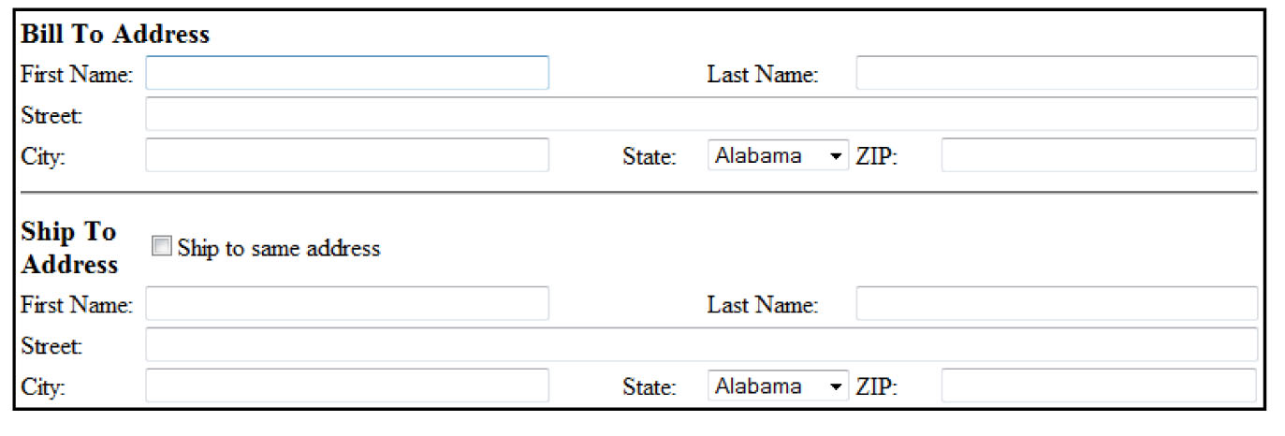
Assignment 2, Part 2 (10 points)
Create a website named ReservationFormExamples.

For this part of the assignment, simply re-write each of the Reservation Form examples used in class as files making up this new, single ReservationFormExamples website.

You will find a new set of steps to follow. The only point to remember when reading the examples is that you are to include them in a single website. To that end please disregard the instruction given for each example that asks you to create a new website. Simply add the new page or pages to the current ReservationFormExamples site.

When completed, your site should have the following folder and file structure:

